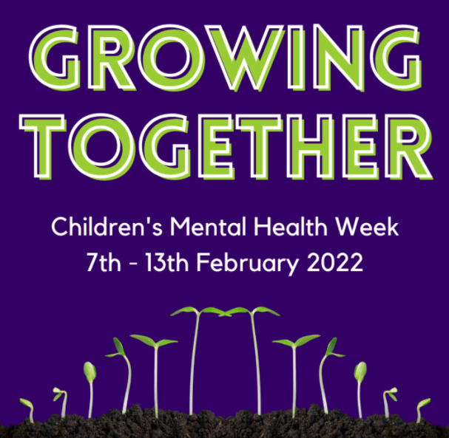
Children’s Mental Health Week
7-13 February 2022

The theme of this year’s Children’s Mental Health Week is Growing Together.

Growing Together is about growing emotionally and finding ways to help each other grow. Challenges and setbacks can help us to grow and adapt and trying new things and help us to move beyond our comfort zone into a new realm of possibility and potential. However, emotional growth is often a gradual process that happens over time, and sometimes we might feel a bit ‘stuck’.

This week we will be helping children to explore what it means to Grow Together. We will be encouraging them to consider how they have grown, and how they can help others to grow.
Share Kindness
We can grow together by being kind. As we grow, there will be times when we struggle or feel uncomfortable emotions. Being kind to ourselves can help us feel good inside and keep trying when things get tricky. Being kind to others can help them to feel happy and positive. Who will you share kindness with today.

Have a Go to Grow
Every day, we try new, exciting things that we might not have done before. It’s OK to find things tricky. We all learn by making mistakes. Being brave and having a go helps us to grow. What are you going to try that’s new today?

Take Time to Grow
When we water a plant, we don’t see it grow straight away. But taking time to give it special care helps it to blossom later. We are the same! Think about what you can do now that you couldn’t when you were smaller. Giving ourselves time when we start doing something new helps us to build confidence and grow step by step. Think today about what you can do now that you couldn’t before.

Growing and Changing
As we grow, we change. Our bodies change as we grow older and our minds and feelings can change too. Sometimes, this happens over a long time and sometimes, things change from day to day. This is OK. Remember, if you’re ever worries about something that’s has changed, speak to an adult you trust in school or at home.
Mrs S Arthur

